Template

✴
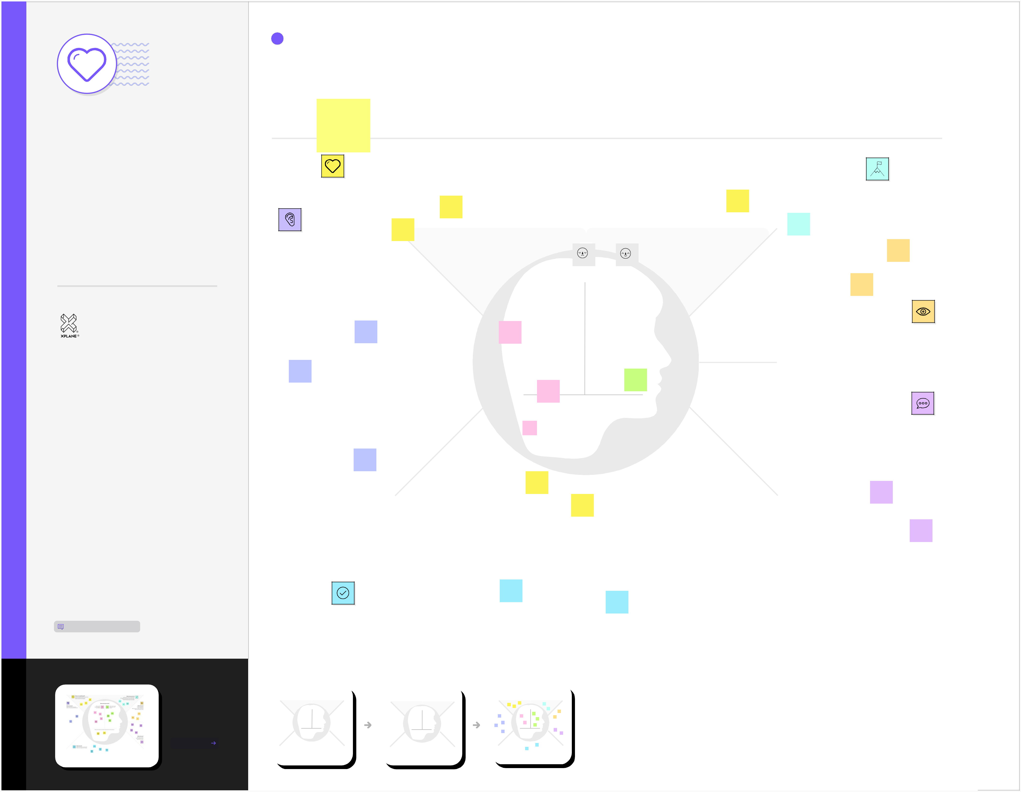

Develop shared understanding and empathy

Summarize the data you have gathered related to the people that are

impacted by your work. It will help you generate ideas, prioritize

features, or discuss decisions.

Empathy map

canvas

Use this framework to empathize with a customer, user, or any person who is affected by a team’s work.

Document and discuss your observations and note your assumptions to gain more empathy for the people you serve.

Originally created by Dave Gray at

TEAM ID

PNT2022TMID26869

WHO are we empathizing with?

Who is the person we want to understand?

What is the situation they are in?

What is their role in the situation?

Thinks in

reduction in

overflows

and landfills

Feels

reduction in

collection

cost

What do they HEAR?

What are they hearing others say?
What are they hearing from friends?

What are they hearing from colleagues?

What are they hearing second-hand?

GOAL

What do they THINK and FEEL?

PAINS |  |  |  | GAINS
What are their fears, |  |  |  | What are their wants,
frustrations, and anxieties? |  |  |  | needs, hopes, and dreams?

 |  | Applying smart waste
 |  | management process
smart waste |  | to the city optimizes
smart waste |  | management,
management |  | management,
management |  | resources and costs
 |  | which makes it a "smart
 |  | city"

What do they need to DO?

What do they need to do differently?

What job(s) do they want or need to get done?

What decision(s) do they need to make?

How will we know they were successful?
DISPLAY: Smart indicators

on the front display panel

DEODORIZER: Foul odor

elimination

DURABLE & LONG LIFE:

Made with high quality

materials for a long durable

life

OPERATION: Automatic sensor

based operation with zero

manual intervention

HYGIENIC: Hygienic disposal

with automatic and touch-less

waste disposal

DISPLAY: Smart indicators on

the front display panel

Smart Dustbin is just a

normal bin where

everyone can dispose

waste but integration of

some hardware

components is done for

more efficient use of

Level of

street

cleanliness

were not

affected

21 standard bins were

replaced with 10

"Compactor smart

bins:. that squash the

bins to fit more in and

remotely report on fill

levels

Knowing the fill-level

of a dustbins without

having to visit the

specific location

makes it easier to

allocate resources

effective

The systems can

be costly initially

because for

more testing

required

Non-uniform

waste

distribution of

waste in bins

It’s difficult to
link systems
from different
vendors

Transparency

and

Sustainability

What do they SEE?

What do they see in the marketplace?

What do they see in their immediate environment?

What do they see others saying and doing?

What are they watching and reading?

What do they SAY?

Encourage recycling-onthe-

go by ensuring

Dustbins aren't overflowing.

Residents will be

encouraged to put the

right thing in the right bin

when they're out and

about.

What other thoughts and feelings might influence their behavior?

waste collection

can use the smart

waste

management

software to

optimize their

collection routes

ENSURE HEALTH AND

SAFETY

WITH SMART DUSTBINS

Smart Dustbin is an intelligent

dustbin that provides you

100%

hygienic solution to everyday

waste management.

What have we heard them say?

What can we magine them saying?

DISPLAY: Smart indicators

on the front display panel

DEODORIZER: Foul odor

elimination

DURABLE & LONG LIFE:

Made with high quality

materials for a long durable

ENSURE HEALTH AND

SAFETY

WITH SMART DUSTBINS

Smart Dustbin is an intelligent

dustbin that provides you

100%

hygienic solution to everyday

waste management.

Share template feedback

Need some

inspiration?

See a finished version

of this template to

kickstart your work.

Open example

 |  | Smart
 |  | Dustbin is
What do they DO? |  | just a
What do they DO? |  | normal bin
What do they do today? | Misunderstanding
What do they do today? | smart sensors
 | of the operations of

 |  | What behavior have we observed? |  |  |  |  |  |  |  |  |  |  |  |  |  |  |  |  |  |  |  |  |  |  |  |  | Applying smart waste
 |  |  |  |  |  |  |  |  |  |  |  |  |  |  |  |  |  |  |  |  |  |  |  |  |  |  | management process
 |  |  |  |  |  |  |  |  |  |  |  |  |  |  |  |  |  |  |  |  |  |  |  |  |  |  | to the city optimizes
 |  | What can we imagine them doing? |  |  |  |  |  |  |  |  |  |  |  |  |  |  |  |  |  |  |  |  |  |  |  |  | management,
 |  |  |  |  |  |  |  |  |  |  |  |  |  |  |  |  |  |  |  |  |  |  |  |  |  |  | resources and costs
 |  |  |  |  |  |  |  |  |  |  |  |  |  |  |  |  |  |  |  |  |  |  |  |  |  |  | which makes it a "smart

